**Problem 6**

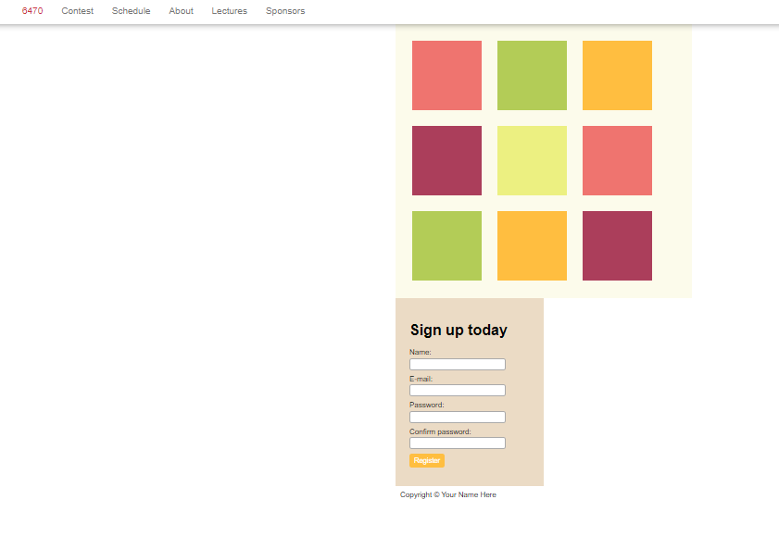

**Index.html**

|  |  |
| --- | --- |
|  | <!DOCTYPE html> |
|  | <html> |
|  | <head> |
|  | <meta charset=utf-8 /> |
|  | <title>HTML/CSS Exercise 5</title> |
|  | <link rel="stylesheet" type="text/css" media="screen" href="[style1.css](http://6.470.scripts.mit.edu/htmlcss/exercises/q5/q5-css.css)" /> |
|  | </head> |
|  | <body> |
|  | <!-- REMOVE_START --> |
|  | <nav> |
|  | <ul> |
|  | <li class="logo">6470</li> |
|  | <li><a href="[#](http://6.470.scripts.mit.edu/htmlcss/exercises/q5/q5-html.html)">Contest</a></li> |
|  | <li><a href="[#](http://6.470.scripts.mit.edu/htmlcss/exercises/q5/q5-html.html)">Schedule</a></li> |
|  | <li><a href="[#](http://6.470.scripts.mit.edu/htmlcss/exercises/q5/q5-html.html)">About</a></li> |
|  | <li><a href="[#](http://6.470.scripts.mit.edu/htmlcss/exercises/q5/q5-html.html)">Lectures</a></li> |
|  | <li><a href="[#](http://6.470.scripts.mit.edu/htmlcss/exercises/q5/q5-html.html)">Sponsors</a></li> |
|  | </ul> |
|  | </nav> |
|  |  |
|  | <div id="container"> |
|  |  |
|  | <div id="main"> |
|  | <div class="style1"></div> |
|  | <div class="style3"></div> |
|  | <div class="style5"></div> |
|  | <div class="style4"></div> |
|  | <div class="style2"></div> |
|  | <div class="style1"></div> |
|  | <div class="style3"></div> |
|  | <div class="style5"></div> |
|  | <div class="style4"></div> |
|  | </div> |
|  |  |
|  | <div id="sidebar"> |
|  | <h1>Sign up today</h1> |
|  | <form action="" method="post" enctype="text/plain"> |
|  | <div class="form_field"> |
|  | <label for="name">Name:</label> |
|  | <input type="text" id="name" name="name" value="" class="text-field"/> |
|  | </div> |
|  | <div class="form_field"> |
|  | <label for="mail">E-mail:</label> |
|  | <input type="text" id="mail" name="mail" value="" class="text-field"/> |
|  | </div> |
|  | <div class="form_field"> |
|  | <label for="password">Password:</label> |
|  | <input type="password" id="password" name="password" value="" class="text-field"></input> |
|  | </div> |
|  | <div class="form_field"> |
|  | <label for="confirm_password">Confirm password:</label> |
|  | <input type="password" id="confirm_password" name="confirm_password" value="" class="text-field"></input> |
|  | </div> |
|  | <div class="form_field"> |
|  | <input type="submit" value="Register" id="submit"></input> |
|  | </div> |
|  | </form> |
|  | </form> |
|  | </div> |
|  |  |
|  | <div id="footer">Copyright © Your Name Here</div> |
|  |  |
|  | </div> |
|  | <!-- REMOVE_END --> |
|  | </body> |
|  | </html> |
|  |  |

CSS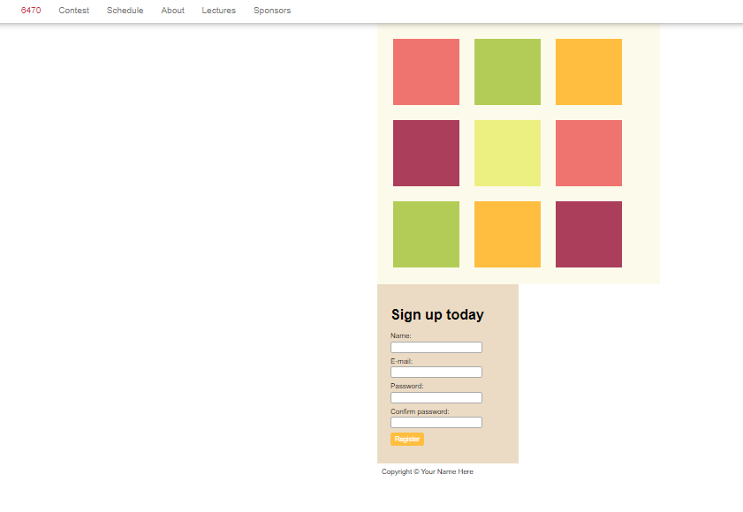

CSS

style1.css

body {

font-family: "HelveticaNeue-Light", "Helvetica Neue Light", "Helvetica Neue", Helvetica, Arial, "Lucida Grande", sans-serif;

margin: 0;

padding: 0;

}

/* Navigation styling */

nav {

-webkit-box-shadow: 0 1px 14px 0 rgba(0, 0, 0, 0.4);

box-shadow: 0 1px 14px 0 rgba(0, 0, 0, 0.4);

font-family: "HelveticaNeue-Light", "Helvetica Neue Light", "Helvetica Neue", Helvetica, Arial, "Lucida Grande", sans-serif;

font-weight: 300;

font-size: 20px;

height: 30px;

padding: 15px 0;

position: relative;

width: 100%;

}

nav a {

color: #777;

text-decoration: none;

}

nav a:hover {

color: #aaa;

}

nav ul {

height: 20px;

list-style-type: none;

margin-top:-10px;

position: absolute;

top:50%;

}

nav li {

float: left;

padding-left:40px;

}

nav .logo {

color: rgb(204, 51, 63);

}

#container {

width: 960px;

margin: auto;

}

/* block full of divs */

#main {

display: inline-block;

background-color: #FCFBEB;

width: 600px; /* why is this not 640px? */

padding: 20px;

overflow: hidden;

vertical-align: top;

}

/* styling divs */

#main div {

border: none;

color: white;

display:inline-block;

height: 150px;

margin: 15px;

padding: 0;

position: relative;

width: 150px;

}

.style1 {

background-color: rgb(239, 116, 111);

}

.style2 {

background-color: #ECF081;

}

.style3 {

background-color: rgb(179, 204, 87);

}

.style4 {

background-color: rgb(171, 62, 91);

}

.style5 {

background-color: rgb(255, 190, 64);

}

/* sidebar containing sign in*/

#sidebar {

display: inline-block;;

background-color: #EBDBC5;

width: 260px; /* related to prev: why not 320px? */;

padding: 30px;

vertical-align: top;

}

/* Styles for the right hand registration panel*/

.form_field {

margin-bottom: 10px;

font-family: "HelveticaNeue-Light", "Helvetica Neue Light", "Helvetica Neue", Helvetica, Arial, "Lucida Grande", sans-serif;

font-weight: 300;

}

.form_field label {

display: block;

margin-bottom: 3px;

}

.text-field {

border: 1px #aaa solid;

border-radius: 5px;

height: 20px;

width: 200px;

}

#submit {

background-color: rgb(255, 190, 64);

border: none;

border-radius: 5px;

color: white;

font-size: 15px;

padding: 5px 10px;

height: 30px;

}

/*

look into border-box regarding previous comments

http://www.paulirish.com/2012/box-sizing-border-box-ftw/

*/

#footer {

padding: 10px;

}